# Maths and Tech assignment

## What is post processing

Postprocessing is the editing of data captured by a camera. Therefore, postprocessing is popular technique within the films and games industry.

## Describe generally the use of post-processing in a graphics application

Snapchat, Instagram, Facebook all have the capabilities to give their users access to post processing effects with the use of user’s phone camera. The technique is referred to as image processing which is the manipulation of each individual pixel within an image so basically just post processing. They use image processing to locate a person’s face, (I’ve not fully looked into the how they determine a person’s face within an image but if I was to guess they probably look for determining features like eyes, nose, mouth and so on). After locating a user’s face, filters can be applied to manipulate the pixels on the image for example you could warp your face to make yourself look weird.

Films use post processing or also known as postproduction to edit and add elements to a film, this will involve graphical applications like photoshop to enhances and edit images.

<https://medium.com/cracking-the-data-science-interview/snapchats-filters-how-computer-vision-recognizes-your-face-9907d6904b91>

Video games are graphical applications that use postprocess effects for things such as screen transitions, god rays, fog, rain drops… this is just a few examples of what can be accomplished with this technique. These effects can help immerse the player for example seeing water run down a window just makes the gameplay feel more real.

## Explain the specific techniques used for your post-processing effects

## Texture passing

Displacement mapping or height mapping is used to tell the shader how to manipulate the pixels this Is usually done with a timer that ranges from 0 to 1, so the effect is slowly applied. The burn process uses a height map which tells the shader what pixels need to be manipulate and which don’t need to be, depending on the timer and the current height.

## Sine wave

Having a timer and using sin wave you are able to create a wiggle effect on the screen, this technique can also be used for other effects like the spiral effect.

## Colour manipulation

I use colour manipulation for the Tint, Grey noise, Invert and Tv processes. So, this technique just means I change the colour of the pixel within the post process shader. For example, the grey noise pixels need to be averaged to look grey this means for each pixel the RGB values are added together and divided by 3.

## Brightness manipulation

To add bloom to the scene you need to render the lights in the scene and turn everything else in the scene to black. To figure out what is a light and what isn’t you would look for the brightest pixels in the scene and any pixels with a brightness of 0.7 or more would be considered a light and would have the bloom effect applied to it.

## Pin Ponging

Pin ponging is a post process technique it uses two textures the reason for this is because you can’t render two effects to the same render target you have to use one texture as the shader resource and the other one as the render target. Otherwise you would just end up with one effect being the effect that is last on the cue. Why is it called ping ponging? The reason it’s called ping ponging is because once you render an effect to a texture that texture must trade places to with the second, the texture will trade places every time a new effect is passed therefore going back and forth i.e. ping ponging. So, one textures is the render target and one is the shader resources and they will switch position every pass of a new effect until the list of effects is empty.

# Discuss improvements or extensions you could make.

## Bloom improvements

To create a post process effect, you must render scene to a texture then send that texture through multiple passes of different postprocess shaders to give the texture different effects. but in many cases the effects are not worth it or complicated effects create performance issues. For example, bloom requires 4 passes of the scene texture to create the effect, first one to extract all the light, second to blur the extracted light horizontally, third to blur the extracted light vertically and lastly combine the blurred light texture with the original scene. A less expensive way to create bloom would be to create a bloom map by using a glossiness map a glossiness map defines the specular highlights per pixel to determine strength and size of the glare of when a light hits it also known as a specular power using this map you can create a fake bloom effect. The advantage of this would be performance the trade-off is a lower quality effect, but most users will not notice the difference.

The addition to of lens flare to the bloom effect would also improve the effect, making it more believable.

## Blur Improvements

Gaussian blur can be improved by using linear sampling instead of point sampling. Linear sampling will grab a collection of pixels from a texture instead of one pixel therefore the process is able to blur multiple pixels every iteration instead of a single pixel resulting in a stronger blur. This method will have the same effect of having multiple point sampling gaussian blurs running on the same image therefore reducing the number of passes.

## Light Beams

The light beams as I like to call them are my attempt of god rays. The way I did this is like the bloom effect but with an extra pass to sample the light texture and move the texture closer and closer toward the camera. It needs improving, the way I would do this is to first create an inclusion pre-pass which is a texture that renders all objects in the scene black and the areas the light can pass through red, you would also require a few if statement to check to see if the object is in front or behind the light source. Then using this new texture I would sample it similar to how I did mine but I would sample it in the direction of the light(this is mainly done with Sun light / directional light, I was using point lights in my example). This will result in a believable god ray / volumetric light scattering.

## Depth of field

Require a few improvements the lights in the scene use additive blending when they are rendered to the scene to blend their models with other areas of the scene, without this there is just a black square with a light in the middle. So, when I removed the background of the scene according to the adjustable depth value the lights had no background to blend with resulting in a black square around each of the lights. I also thought about how I would fix this and if I did the lights would still have issues.

The depth of field that I implemented doesn’t use the circle of confusion or COC this would be a future improvement this effect.

<https://community.arm.com/developer/tools-software/graphics/b/blog/posts/post-processing-effects-on-mobile-optimization-and-alternatives>

# Basic Requirements

I achieved everything required for the basic requirements

# Advanced Requirements

## Tint hue

Gradient tint required the use of the lerp function, the lerp function is used here to change the colour of the screen depending on the two selected colours by the user using the GUI. the colour of the screen will lerp between the two colours using the vertical position of the pixel. As you can see from the image on the right you can set a top colour and a bottom colour, and these are the colours that the shader will lerp between.

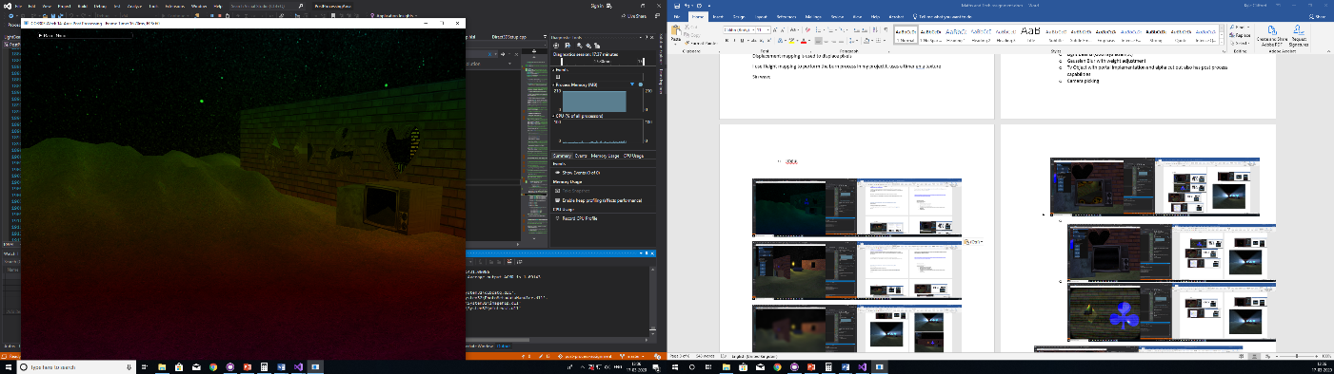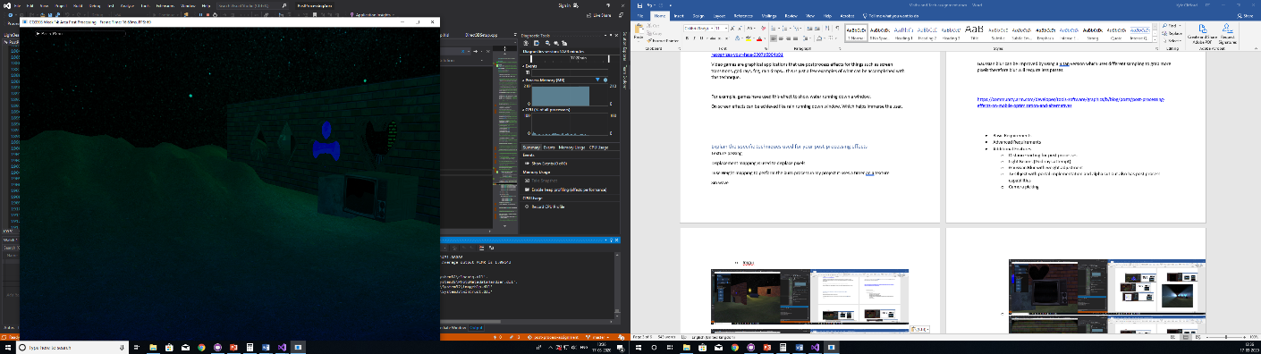

By converting the RGB colour to HSL you can vary the colours by adding a timer to the hue variable. The tint colour will slowly move through the colour spectrum.

## Bloom

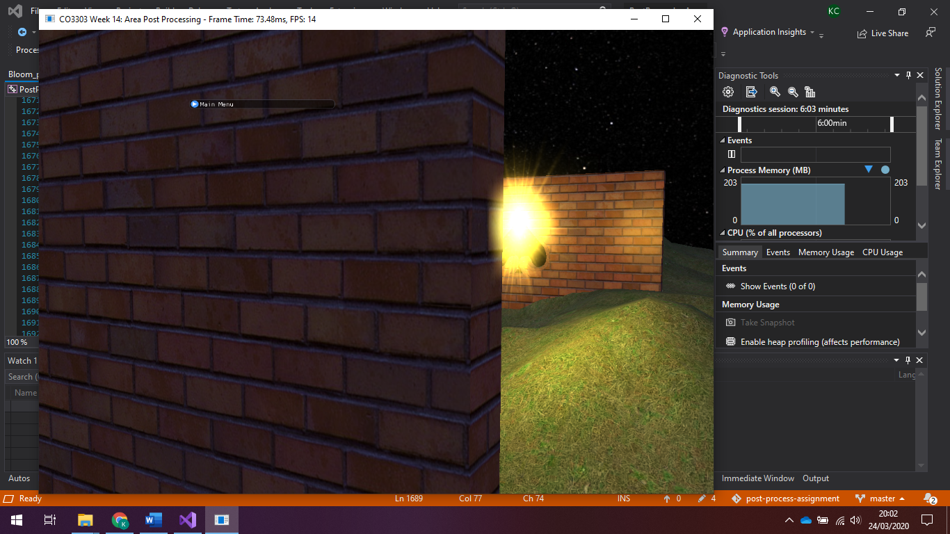Bloom Is created by filtering out all the bright pixels in a texture blurring them then adding them back to the original scene. This will cause the lights to get bigger and brighter due to them being blurred. As you can see from the image on the right the light bleeds into the objects. This was a difficult process trying to figure out how to make a copy of the scene and when to make a copy. To make this effect work with other effects I had to make the copy of the scene at a correct time others wise you could lose some of the other effects for example if you made a copy of the scene before applying the post process effects the image would lose all the effects applied before the bloom. The only thing I didn’t add to the bloom was lens flare.

## Gaussian Blur

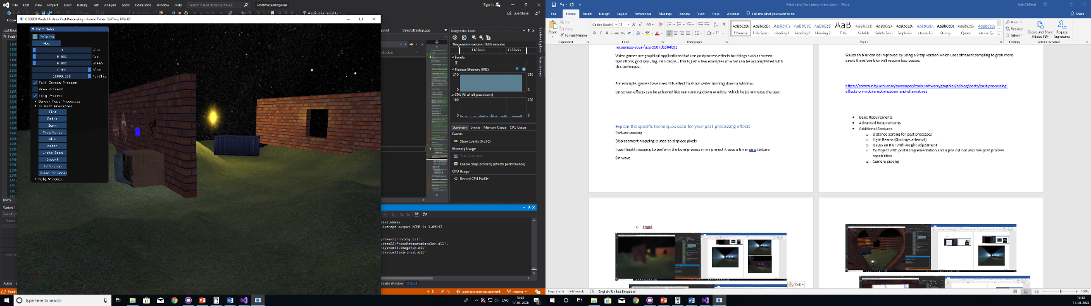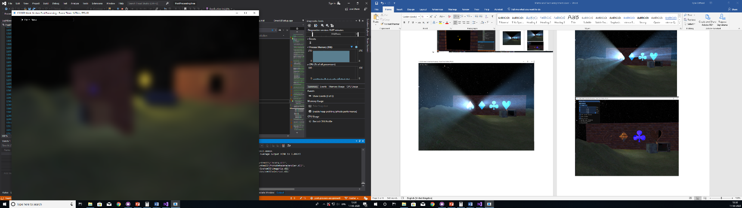

Gaussian blur is achieved by grabbing pixels from different areas of the image and adding them to the current pixel. This requires an offset and weights. Weights also known as normal distribution or gaussian kernel is a grid of numbers that all add up to equal 1 usually. Weights tell the blur how much colour it needs to sample from the given pixel and the offsets just determine what pixel to look at.

The weights are created in real time and can be adjusted using the slider on the GUI labelled Blur.

## Retro

Retro post processing was done by rounding the current pixel to the position of another pixel this is done using a function called Floor, floor basically rounds the pixel coordinates to a specific section if you was to visualize this it would look like a square grid across the image you would increase the size of these squares by implementing the size of the pixels using there heights and width and multiplying them by how big you want them to be, now with this you can tell the pixel to sample the colour in the centre of their specific section of the grid.

Also to give a more retro effect I limited the colour range I did this by rounding numbers up to 1 decimal place therefore limiting the colour range.

## Depth of Field

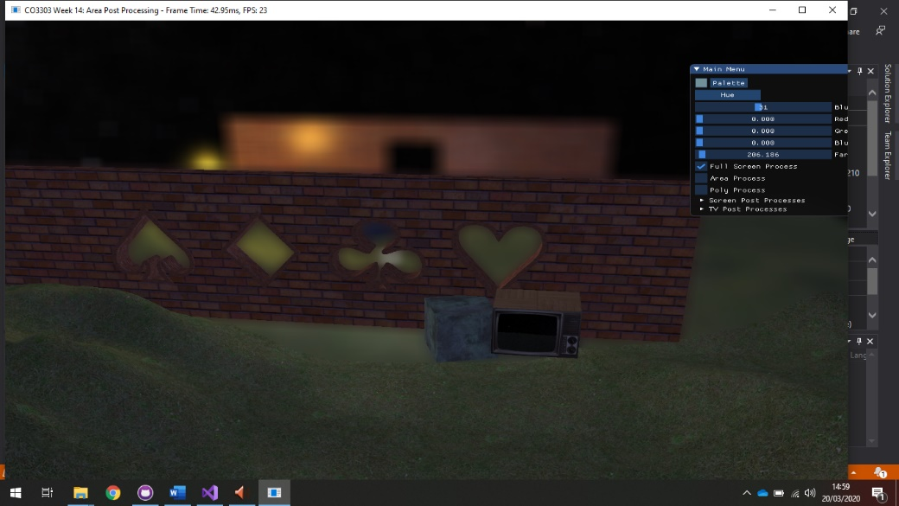To create depth of field you would use a Depth texture to locate how far away an object is away from the camera this helps the depth buffer figure out what objects are in front of other objects if you could manipulate this data you could remove parts of the image depending on how far away they are I couldn’t get this to this way to work. I found a fake way of creating the effect using the cameras far clip distance. By manipulating the cameras far clip distance you can control how far away the camera can see (render) using this I captured an image of the scene with a far clip that was close to the camera and one that was far away. I then blurred the image with the furthest far clip i.e. the background and then added the other scene texture over the top. This creates the depth of field effect shown on the right. I added a slider to the GUI to control the far clip and therefore controlling the distance of the blur.

# Additional Features

## Distance sorting for post processes

Polygon post processing has a lot of issues one of them is sorting. in my project I put all the polygon postprocess onto a list that would be processed in a linear way, meaning that the process at the beginning of the list always had priority over the others processes, for example if I have one polygon with the water process and the another polygon with the burn process, if you lined these two polygons up and looked through the water polygon into the burn polygon it would look normal but if you reversed this and looked through the burn polygon in to the water polygon, the water polygon would over lap the burn process. EXAMPLE PIC MAYBE

To solve this, I sorted the polygon postprocess list by closest to furthest using the distance from the camera to the polygon. This meant I was able to render the processes depending on their distance from the camera this solved all the sorting issues.

I had other sorting issues when using full screen and polygon post processing, where the polygon post process would overlap the full screen for example if I had tint on the full screen and a spiral on the polygon the tint on the full screen wouldn’t affect the spiral at all this is due to the spiral being rendered after the full screen. To solve this, I just rendered the full screen post processing effects after the polygon and area effects.

## Light Beams (God rays attempt)

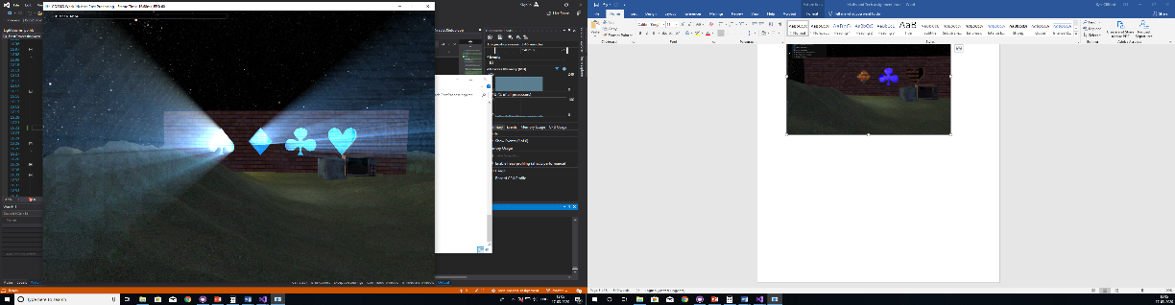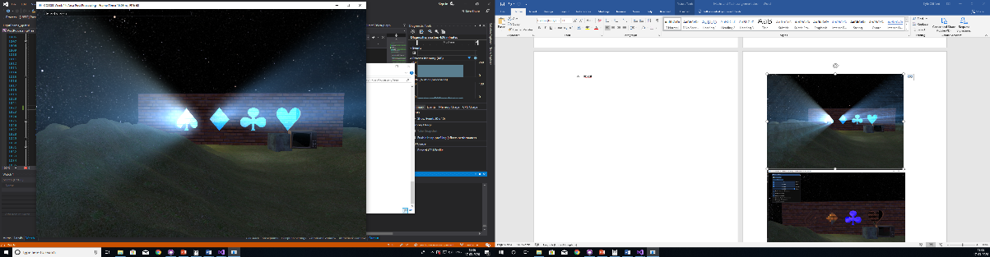

I attempted to add light scattering or also known as god rays to my project as shown by the image on the right. the way I did this didn’t work correctly the light would move with the camera and this due to me not setting the direction of the light properly. The way I did this effect is similar to the bloom effect but I added a new step that sampled the image over and over while getting closer to the camera, the first image on the right shows the effect without any blurring at all if you look closely you can see the repetitive lines of each sample. The second image shows the effect when the samples are blurred which creates a smother and nicer effect to look at.

## Gaussian Blur with weight adjustment

Adding gaussian blur is simple to do but making the gaussian weight kernel adjustable is quite difficult because there are a few things that need to be done. Firstly, HLSL doesn’t support dynamic arrays so away around this is initializing a normal array with a large size. For my implementation I set the size of the array to 256 anything more then this then the device would start to struggle.

The next issue is calculating the weights on the CPU and not the GPU. To send information to GPU through constant buffer you need to send data over in 4 bytes this meant when sending over the weights over as float4s instead of just normal floats. When trying the to access the weights in HLSL only the .r or .x value would hold the correct values for the weights the .gba or the .yzw are used as packing.

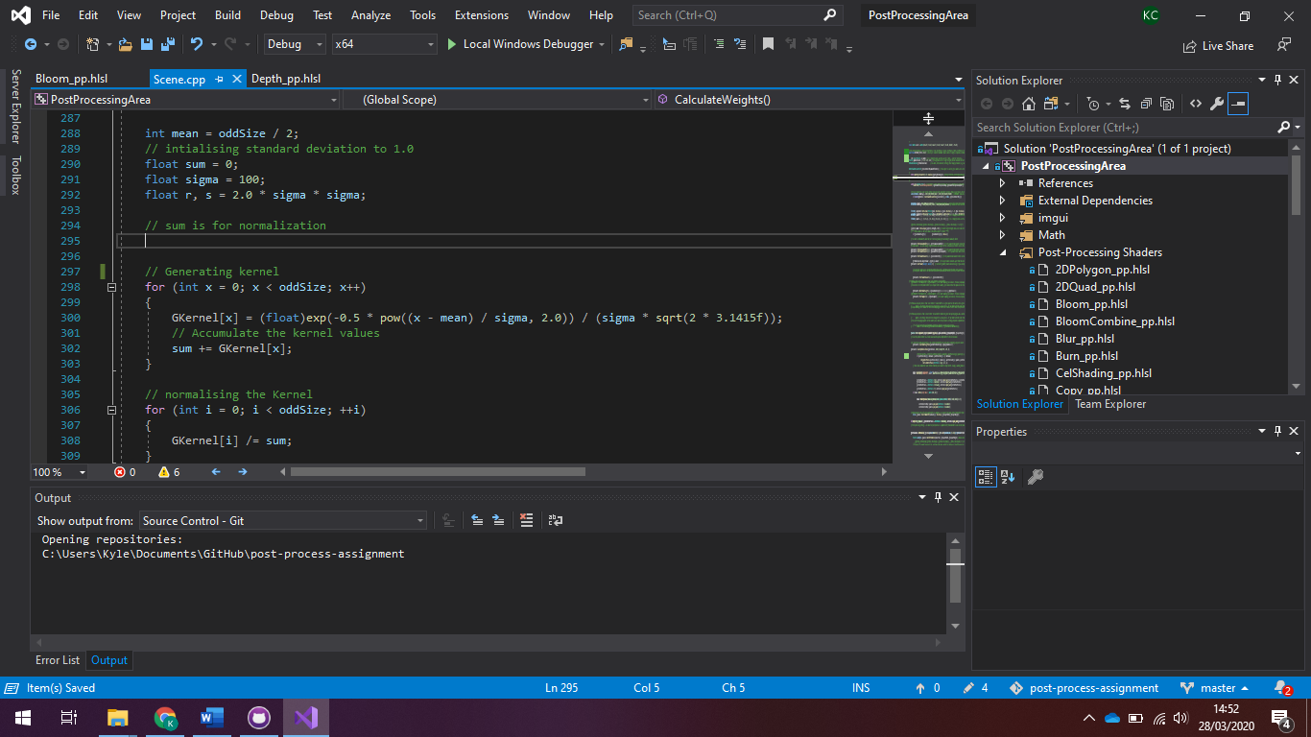The image on the right shows a function populating an array using the Gaussian formula once the array is populated it then needs to be normalized so that when all the values are added up, they will equal 1.

The kernel size can be adjusted by giving the function a size the size will be rounded down to the nearest odd number, because the size can be increased this means the sigma of the gaussian function must also be increased the sigma spreads out the weight more across the array otherwise some of the values in the array would equal zero and will prevent the effect form working.

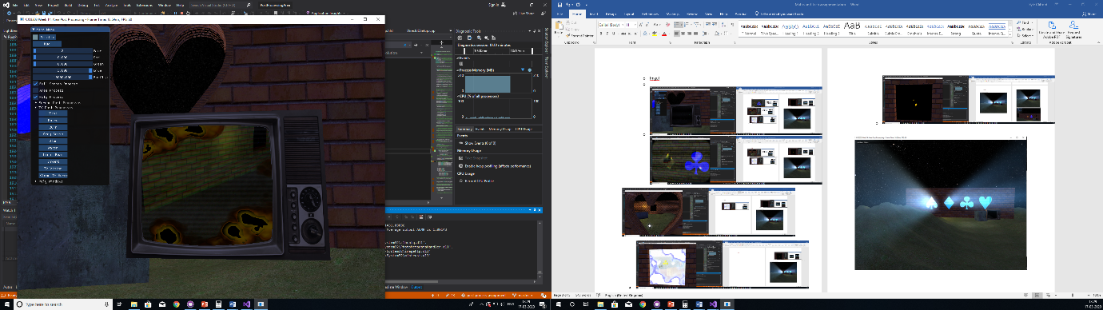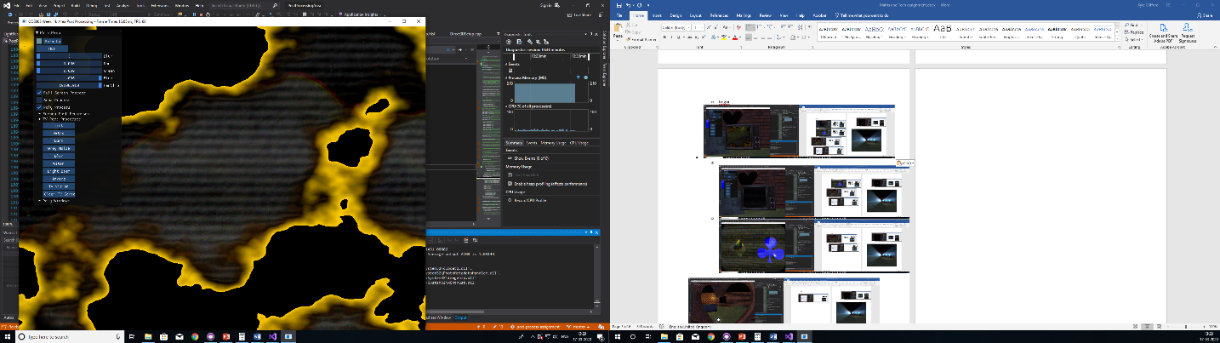

## TV Model

I took the second-year portal lab implementation and added it to this project. The portal lab includes a TV image which has a black screen, the black screen has a different alpha value compared to all the other parts of the TV using this you can apply an image to the TVs black screen. I created a second camera made it rotate the around the origin of the scene and rendered it to a texture I then applied the texture to the tv. After doing this I was able to add post processing effects to this new texture which will show up on the TV model in the project. The TV texture can have multiple post processing effects applied to it. Also, when the user flies through the tv screen the post process that were on the TV will now be on the user’s full screen and the position of the user will be set to the position of the TVs Camera.

## TV Scanlines

The TV scan lines are an additional shader that I added, it adds black lines to the screen and makes the lines slowly go up the screen, random noise is also active on the screen which looks like static and finally the screen colour is tinted to mimic an old CRT screen.

## Camera picking

You are able to move the objects around in the scene the only objects in the scene that cannot be moved are the floor and the skybox, by clicking on these objects you can select what object you want to apply area post processing on, holding down the left click will allow you to move objects, scrolling the mouse wheel will allow the user to set the distance of the object and the <> keys control the Y axis rotation.

I spent ages on trying to implement camera picking and I couldn’t fix one issue this issue being that if you move the camera the picking will stop working as intended I tried transposing the matrix of the camera, updating the matrix with the new position but none of my attempts worked therefore the camera picking only works when the program is initially started up and the camera is static.

## Imgui

IMGUI is a Graphical User Interface it is very useful in this project because it means you can have less keys on the keyborading doing stuff and its more intuitive as I don’t have to explain what everything does because it is all labeld and easy to understand.

* + 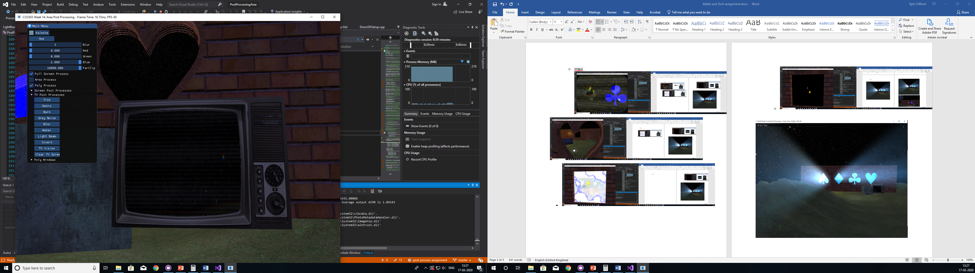
  + 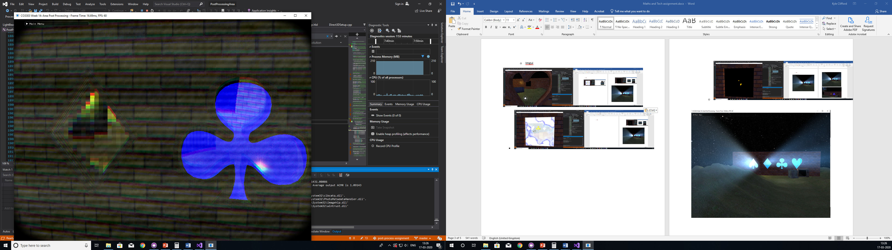

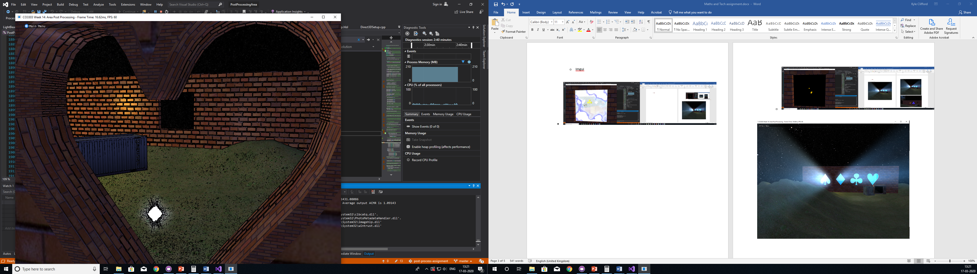

* 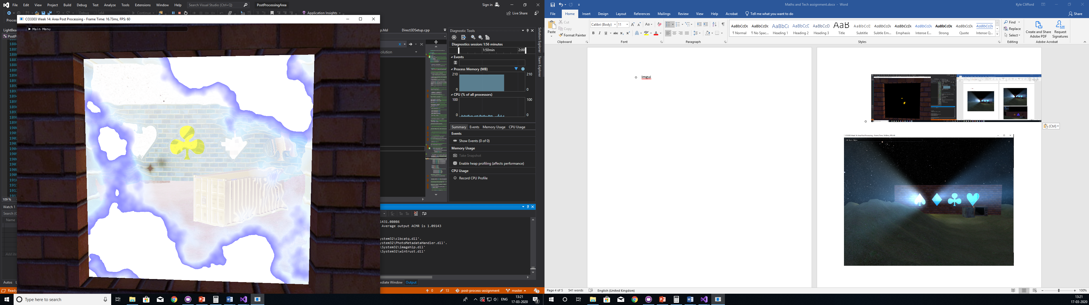
  + a